Parameter setting of 2 in 1 color hotend slicing software

Slicing software：Cura-15.04

Machine settings ：

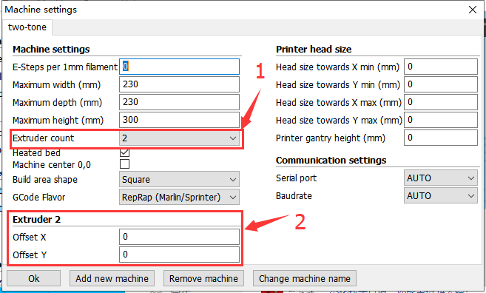

1. Set the extruder count : 2;
2. Set the distance between the nozzle（If it's two in one out extruder, it is set to 0)

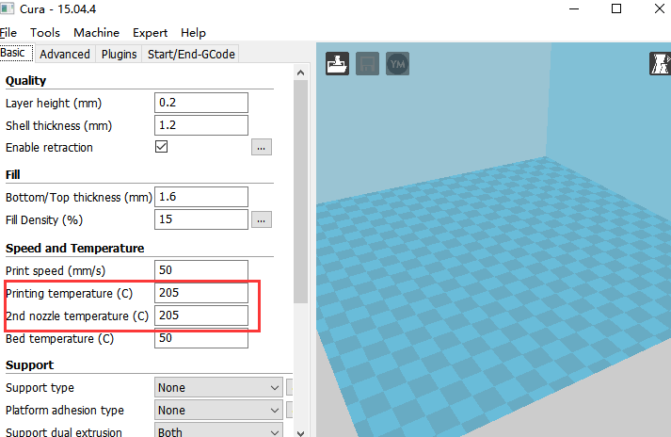

Set the printing temperature of each nozzle.(If it is the same type of printing supplies, set the same temperature)

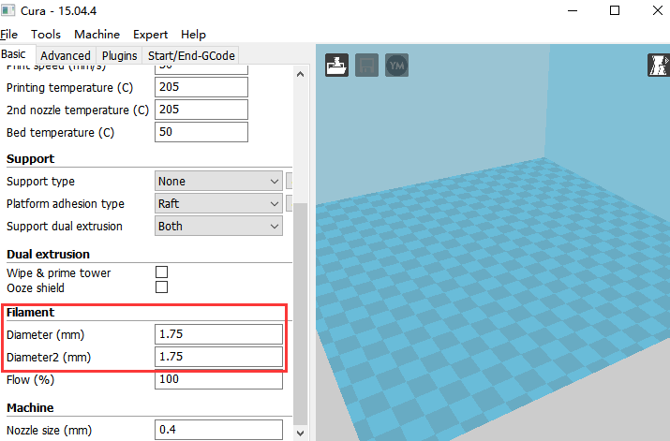

Set the print consumable diameter of each filament hole to 1.75mm.

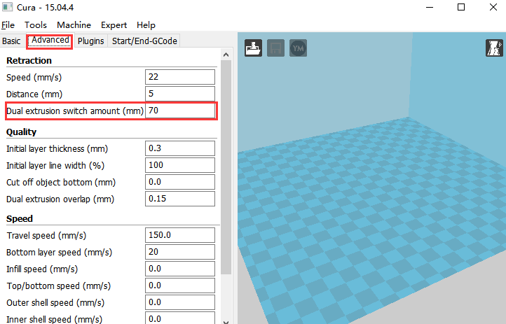

Set the exit length when switching filament during printing.(According to the actual extruder setting,If it is not a mixed color nozzle, it is recommended to be more than 50mm.)

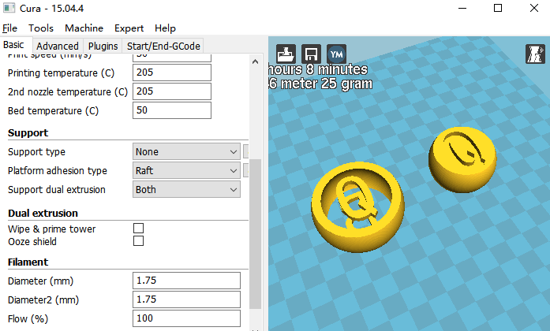

Load and import the two-color model STL.

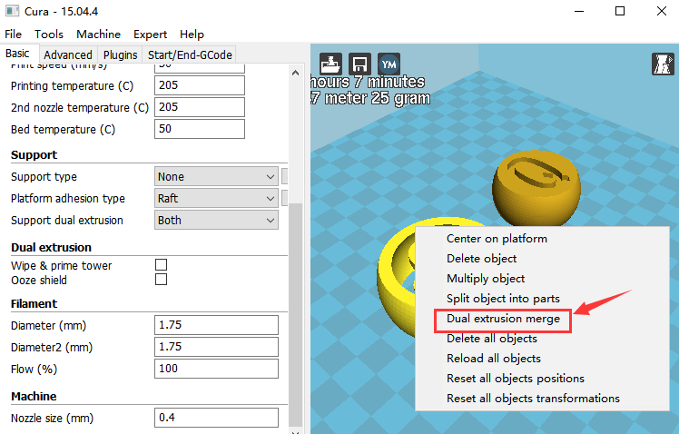

Right-click on the model and select dual extrusion merge to print the model.

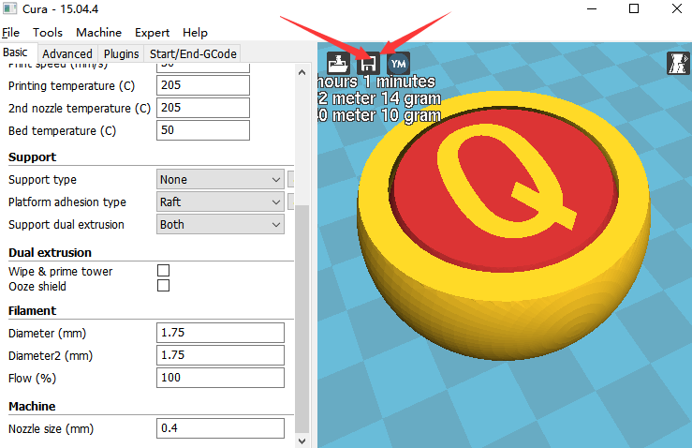

Finally, save the slice and print it.